Wildflowers of St. Mary’s Churchyard, Billingshurst

Through sensitive management churchyards can be amazing places for wildlife. St Mary’s Churchyard at Billingshurst is home to a wealth of beautiful wildflowers which in turn provide vital energy for local butterflies, bees and many other insects.

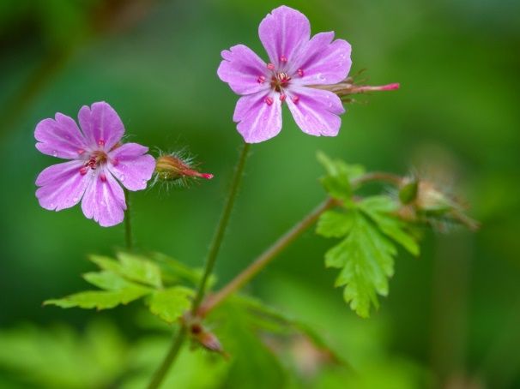
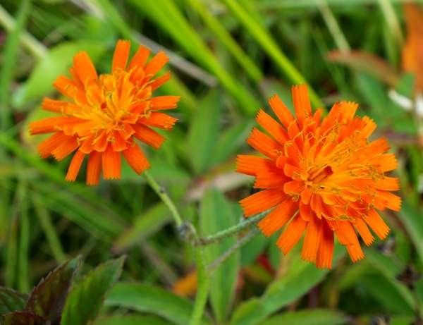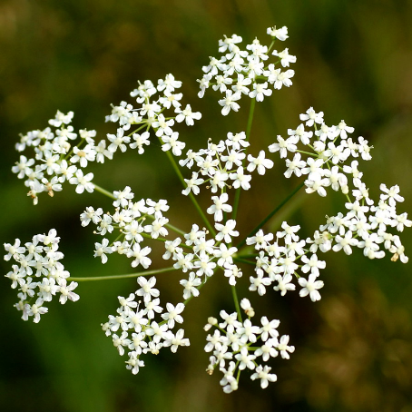
Fox & Cubs Burnet Saxifrage Herb Robert
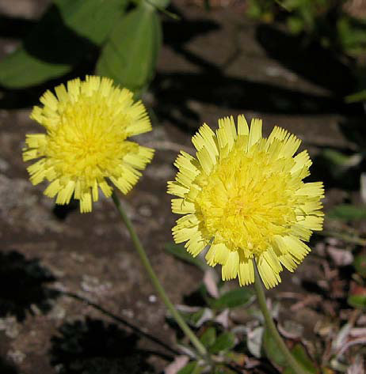
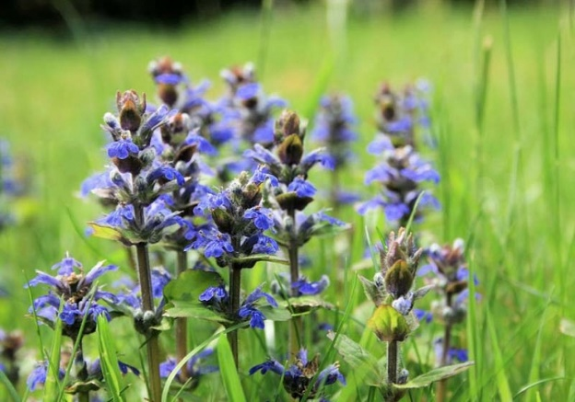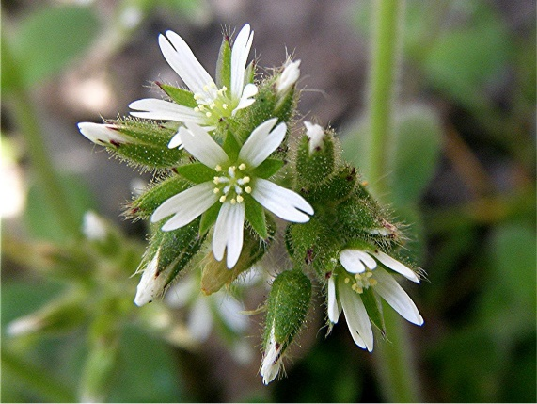
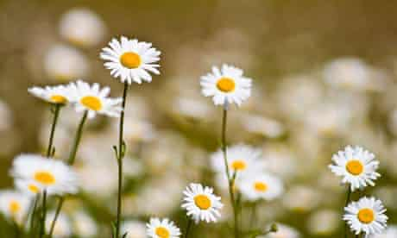
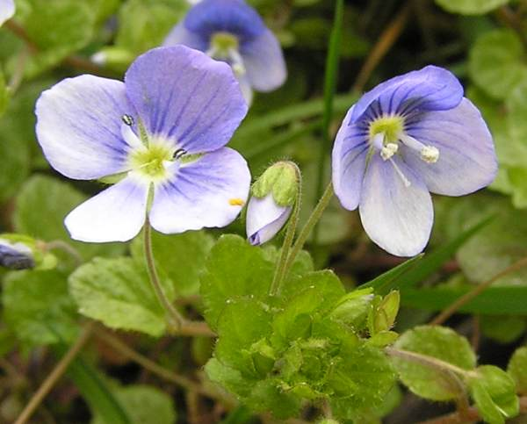
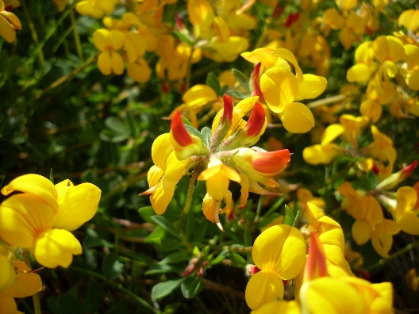
Bugle Sticky Mouse-ear Mouse-eared Hawkweed

Bird’s Foot Trefoil Slender Speedwell Oxeye Daisy
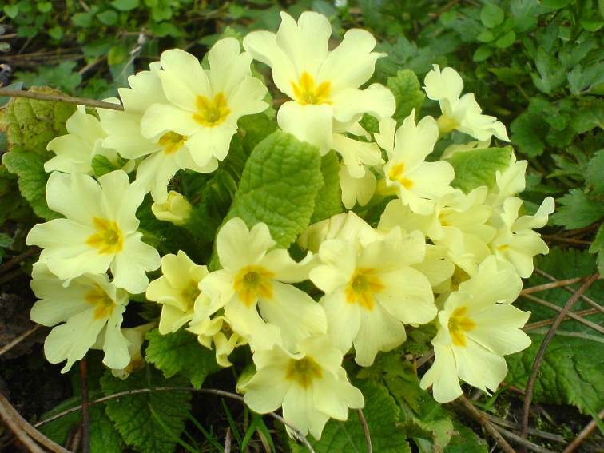
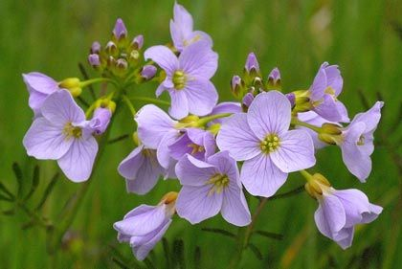
Cuckooflower Primrose
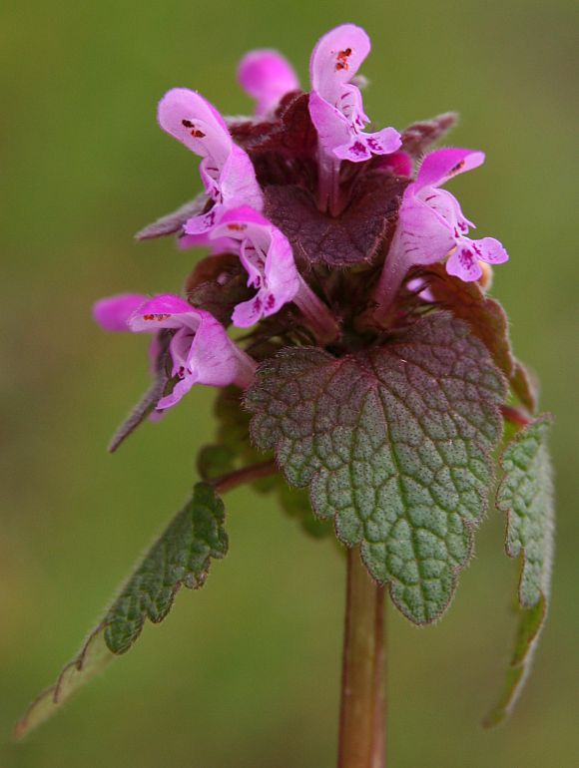
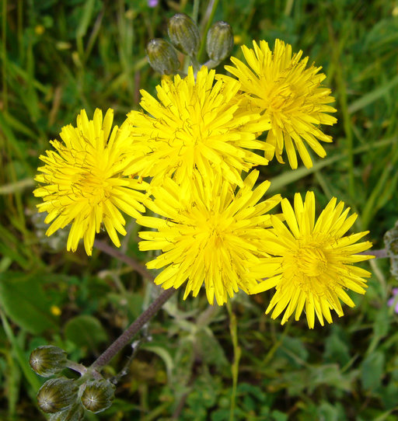
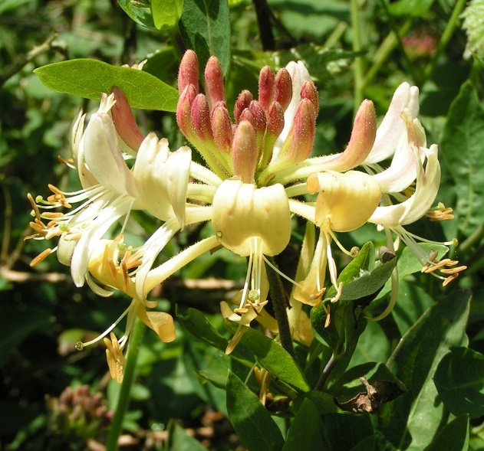

Red Deadnettle Beaked Hawksbeard Honeysuckle
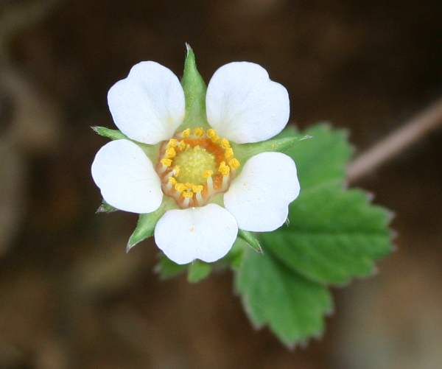
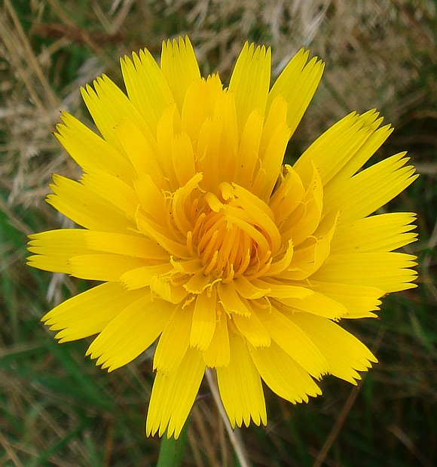
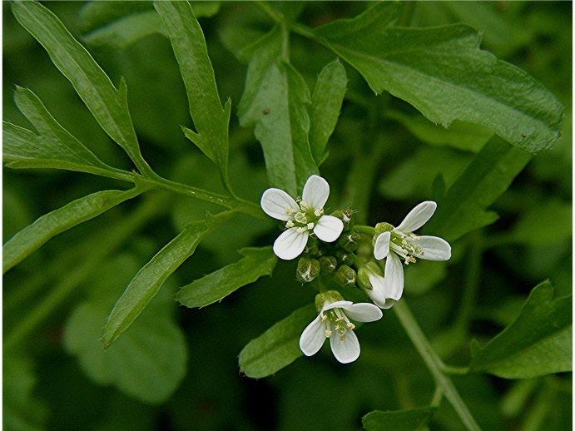

Wavy Bittercress Cat’s Ear Barren Strawberry

The following species were recorded at St. Mary’s, Billingshurst by the Sussex Botanical Recording Society.

Acer pseudoplatanus | Sycamore
Achillea millefolium | Yarrow
Aegopodium podagraria | Ground-elder
Agrostis capillaris | Common Bent
Ajuga reptans | Bugle
Alliaria petiolata | Garlic Mustard
Alopecurus pratensis | Meadow Foxtail
Anisantha sterilis | Barren Brome
Anthoxanthum odoratum | Sweet Vernal-grass
Anthriscus sylvestris | Cow Parsley
Arrhenatherum elatius | False Oat-Grass
Arum maculatum | Lords-and-Ladies
Asplenium scolopendrium | Hart's-tongue
Bellis perennis | Daisy
Brachypodium sylvaticum | False-brome
Calystegia silvatica | Large Bindweed
Cardamine flexuosa | Wavy Bitter-cress
Cardamine pratensis | Cuckooflower
Carex divulsa subsp. divulsa | Grey Sedge
Centaurea nigra | Common Knapweed
Cerastium fontanum | Common Mouse-ear
Cerastium glomeratum | Sticky Mouse-ear
Cirsium palustre | Marsh Thistle
Convolvulus arvensis | Field Bindweed
Crataegus monogyna | Hawthorn
Crepis capillaris | Smooth Hawk's-beard
Crepis vesicaria | Beaked Hawk's-beard
Dactylis glomerata | Cock's-foot
Epilobium ciliatum | American Willowherb
Epilobium montanum | Broad-leaved Willowherb
Euphorbia peplus | Petty Spurge
Festuca rubra agg. | Red Fescue
Ficaria verna | Lesser Celandine
Fraxinus excelsior | Ash
Galanthus nivalis | Snowdrop
Galium album | Hedge Bedstraw
Galium aparine | Cleavers
Geranium dissectum | Cut-leaved Crane's-bill
Geranium robertianum | Herb-Robert
Geum urbanum | Wood Avens
Glechoma hederacea | Ground-ivy
Hedera helix | Common Ivy
Heracleum sphondylium | Hogweed
Holcus lanatus | Yorkshire-fog
Hordeum murinum | Wall Barley
Hypericum perforatum | Perforate St John's-wort
Hypochaeris radicata | Cat's-ear
Ilex aquifolium | Holly
Iris foetidissima | Stinking Iris
Lamium album | White Dead-nettle
Lamium purpureum | Red Dead-nettle
Lapsana communis | Nipplewort
Leontodon hispidus | Rough Hawkbit
Leontodon saxatilis | Lesser Hawkbit
Leucanthemum vulgare | Oxeye Daisy
Lolium perenne | Perennial Rye-grass
Lonicera periclymenum | Honeysuckle
Lotus corniculatus | Common Bird's-foot-trefoil
Luzula campestris | Field Wood-rush
Medicago lupulina | Black Medick
Myosotis arvensis | Field Forget-me-not
Myosotis sylvatica | Wood Forget-me-not
Narcissus agg. | Cultivated Daffodil
Parietaria judaica | Pellitory-of-the-Wall
Parthenocissus quinquefolia | Virginia-creeper
Pilosella officinarum | Mouse-ear-hawkweed
Pimpinella saxifraga | Burnet-saxifrage
Plantago lanceolata | Ribwort Plantain
Plantago major | Greater Plantain
Poa annua | Annual Meadow-grass
Poa pratensis | Smooth Meadow-grass
Poa trivialis | Rough Meadow-grass
Potentilla reptans | Creeping Cinquefoil
Potentilla sterilis | Barren Strawberry
Primula vulgaris | Primrose
Prunella vulgaris | Selfheal
Prunus laurocerasus | Cherry Laurel
Pseudofumaria lutea | Yellow Corydalis
Quercus robur | Pedunculate Oak
Ranunculus acris | Meadow Buttercup
Ranunculus repens | Creeping Buttercup
Rubus fruticosus agg. | Bramble
Rumex acetosa | Common Sorrel
Rumex crispus | Curled Dock
Rumex obtusifolius | Broad-leaved Dock
Rumex sanguineus | Wood Dock
Sagina apetala subsp. apetala | Annual Pearlwort
Sambucus nigra | Elder
Scorzoneroides autumnalis | Autumn Hawkbit
Sedum acre | Biting Stonecrop
Senecio erucifolius | Hoary Ragwort
Senecio jacobaea | Common Ragwort
Senecio vulgaris | Groundsel
Solanum dulcamara | Bittersweet
Sonchus asper | Prickly Sow-thistle
Sonchus oleraceus | Smooth Sow-thistle
Stachys sylvatica | Hedge Woundwort
Stellaria graminea | Lesser Stitchwort
Stellaria holostea | Greater Stitchwort
Tamus communis | Black Bryony
Taraxacum agg. | Dandelion
Taxus baccata | Yew
Trifolium dubium | Lesser Trefoil
Trifolium pratense | Red Clover
Trifolium repens | White Clover
Ulmus procera | English Elm
Urtica dioica | Common Nettle
Veronica arvensis | Wall Speedwell
Veronica chamaedrys | Germander Speedwell
Veronica filiformis | Slender Speedwell
Veronica hederifolia | Ivy-leaved Speedwell
Vicia sativa subsp. segetalis | Common Vetch
Vicia sepium | Bush Vetch
Viola riviniana | Common Dog-violet
Surveyed on 07/06/16, 17/08/16 & 06/04/17
By Miss F. Abrahams.
(Sussex Botanical Recording Society).

